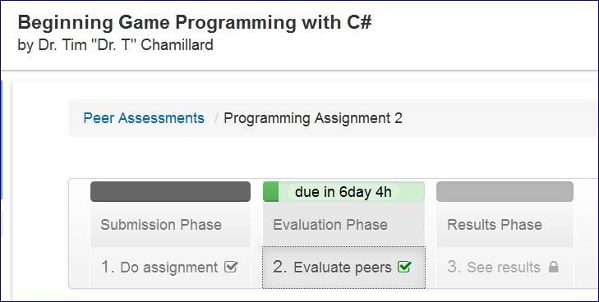

**Assignment Description**

The big idea behind this assignment is that you'll write a program that displays a random sprite in a random location in the window. Approximately each second, you'll generate a new random sprite and location (the old sprite will go away). The other skill you'll be working on is reading class documentation, since you'll need to find details about the Random class that I haven't provided to you in class or the book.

I've posted a project that you should use as your starting point for this assignment to the Required Assessment Materials course page (ProgrammingAssignment2Materials.zip); please be sure to start with that. The project includes comments in the code indicating where you should add your own code or modify the provided code; all those comments start with the word STUDENTS. Changing code that I already provided to you, except where indicated, is both unnecessary and unwise.

**PEER GRADING**

After submitting your work (described also in the two question parts below), you'll get the chance to grade the work of **five** of your peers.  Your own work will also be assessed by your peers, from which we'll get your grade. Since you've worked hard on your submission and would like your peers to do a good job of assessing your submission, please take your time and do a good job of assessing your peer's submission in return. After you've completed your peer assessments, you'll go back and self-assess your own submission.

**HONOR CODE**

Please remember that you have agreed to the Honor Code, and your submission should be entirely yours. Our definition of plagiarism follows from standard literature: passing off someone else's work as your own, whether from your peer or Wikipedia.

**Assignment Steps**

Completing the following steps should get you through the assignment successfully.

1. Download the ProgrammingAssignment2Materials.zip file from the Required Assessment Materials course page and save and extract it to a location of your choice
2. Copy five images of your choice into the Content folder of the ProgrammingAssignment2Content project
3. Start up the IDE and open the project
4. Add the five images from the Content folder as Existing Item … to the ProgrammingAssignment2Content project
5. Add variables to hold five Texture2D sprites near the top of the Game1 class
6. Run your program to make sure it compiles and runs
7. Load the sprites in the LoadContent method and change the code as indicated by BOTH the comments
8. Run your program to make sure it compiles and runs
9. Modify the code in the Update method as indicated by the LAST comment; don’t do the rest yet
10. Add code to the Draw method to draw currentSprite using drawRectangle
11. Run your program to make sure it compiles, runs, and draws a sprite in the upper left corner
12. Modify the code in the Update method as indicated by the FIRST TWO comments. Don't do the rest yet.
13. Run your program to make sure it compiles, runs, and draws a sprite in the upper left corner. The sprite should change approximately every second
14. Modify the code in the Update method as indicated by the THIRD comment. Don't do the rest yet.
15. Run your program to make sure it compiles, runs, and draws a sprite. The sprite and the x location of the sprite should change approximately every second. The sprite should always be completely in the window
16. Modify the code in the Update method as indicated by the FOURTH comment.
17. Run your program to make sure it compiles, runs, and draws a sprite. The sprite and the location of the sprite should change approximately every second. The sprite should always be completely in the window
18. You're done!

Your solution to this problem must:

* Meet the problem specification (e.g., do what it’s supposed to)
* Comply with the course coding standards

**Turning in your assignment**

You have to do all of the following steps to submit by the due date:

1.       Copy and paste your entire Game1.cs file into the first text box below

2.       Upload a short video (less than 1 minute) of your "game" to YouTube. You can capture a video of your "game" as it runs using the free Fraps software ([www.fraps.com](http://www.fraps.com)) or some other capture software

3.       Upload a link to your YouTube video by copying and pasting the link into the second text box below

4.       Click the Submit for grading button

---===================================================

This portion of the assignment is about using appropriate data types and the coding style in your program. This portion of the assignment is worth 4 points.  
  
Copy and paste your entire Game1.cs file into the text box below. Clicking the < code > tab at the top of the text box and pasting inside the resulting grey box will keep all your spacing intact.

**Evaluate the source code for the following 4 criteria:**

1. Appropriate data types for variables
2. Descriptive names and proper capitalization for variable names
3. A line comment directly above the code implementing each chunk of commented code (no blank line between comment and code it comments)
4. A blank line or open curly bracket above each line comment

---===================================================

### There are a number of major problems with the approach described below. I'm working with Coursera to try to figure out a way for you to upload a video file here instead of using the link to a video approach. If this takes longer than I hope it will to resolve, I'll extend the due date for this assignment until we figure it out. Sorry for the inconvenience.

This portion of the assignment is about correct program behavior. This portion of the assignment is worth 4 points.   
  
Upload a short video (less than 1 minute) of your "game" to YouTube. You can capture a video of your "game" as it runs using the free Fraps software ([www.fraps.com](http://www.fraps.com)) or some other capture software.   
  
Upload a link to your YouTube video by copying and pasting the link into the text box below.   
  
Note: I understand YouTube may not be available to all students in the course. Although it's the preferred hosting platform, including a link to the video hosted on some other reputable video hosting platform is acceptable.

**Evaluate the video for the following 4 criteria:**

1. Randomly picks one of 5 different sprites. Makes sure all 5 sprites appear in the video (if all 5 don't appear in the video, check the source code to make sure they used 5 as the (exclusive) upper bound when they generated a random sprite number)
2. Sprite image changes approximately every second
3. Sprite location changes approximately every second (with random numbers, 2 or more locations could be very close as the image changes, but at some point in the video the location should be different)
4. Sprite images are always completely inside the window